Mandelbrot Set – Part 3  
Numerical Scientific Computing Mini-Project

**Name:** Lukas Bisgaard Kristensen

**Date:** 26/04/2023

**Program:** Computer Engineering (AVS), 8th semester, Aalborg University

**Course:** Numerical Scientific Computing

# Docstrings and Doctests (3 cases), see mandelbrot_vectorized.py

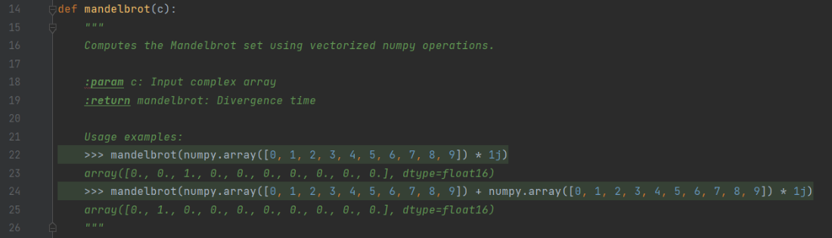

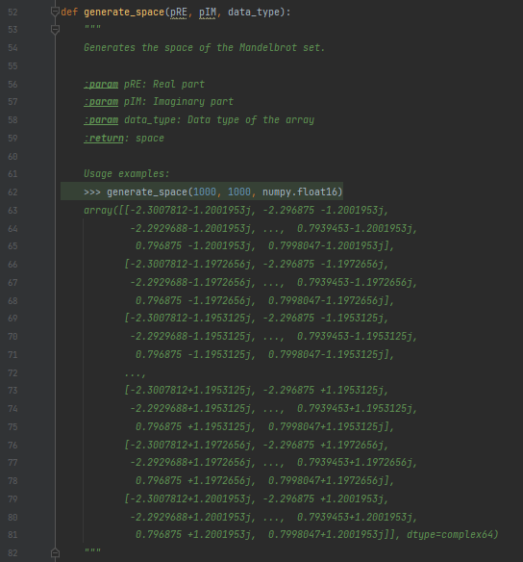

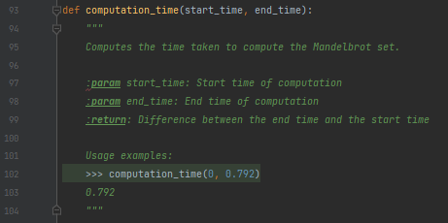

# OpenCL with defined memory types for all variables

__global memory data type for the input and output data.

__private memory data type for data that is only relevant for workers within the function.

# Benchmarking results for grid-sizes across computation parameters

# Extra features

* Zoom Animation
  + Code: mandelbrot_iteration_animation.py
    - GitHub: <https://github.com/LukasKristensen/Mandelbrot-Python/blob/main/Iterations%20Animation/mandelbrot_iteration_animation.py>
  + Video of output: <https://www.youtube.com/watch?v=L2zKIrriDfI>
* Iteration Animation
  + Code: mandelbrot_animation.py
    - GitHub: <https://github.com/LukasKristensen/Mandelbrot-Python/blob/main/Zoom%20Animation/mandelbrot_animation.py>
  + Video of output: <https://www.youtube.com/watch?v=8BjqgaIuses>